1. Description of the Dataset & Machine Learning Problem
The dataset under study contains various statistics of NBA players, including their game performance metrics. It has 22 columns and 1340 entries, with each entry representing an individual player. The columns represent different attributes of a player's game, such as:
- 'gp': the number of games played,
- 'min': minutes played per game,
- 'pts': points per game,
- 'fgm': field goals made per game,
- 'fga': field goal attempts per game,
- 'fg': field goal percentage,
- '3p_made': 3-point field goals made per game,
- '3pa': 3-point field goal attempts per game,
- '3p': 3-point field goal percentage,
- 'ftm': free throws made per game,
- 'fta': free throw attempts per game,
- 'ft': free throw percentage,
- 'oreb': offensive rebounds per game,
- 'dreb': defensive rebounds per game,
- 'reb': total rebounds per game,
- 'ast': assists per game,
- 'stl': steals per game,
- 'blk': blocks per game,
- 'tov': turnovers per game.
The 'name' column represents the name of the player, and the 'target_5yrs' column is the target variable, which indicates whether the player lasted in the NBA for 5 years or more (1 if yes, 0 otherwise).
The task at hand is a binary classification problem, where the objective is to predict whether a given NBA player will last in the league for 5 years or more based on their performance statistics. This problem is of interest as it can help teams in their decision-making processes, such as player recruitment and development.
Here's a glimpse of dataset :
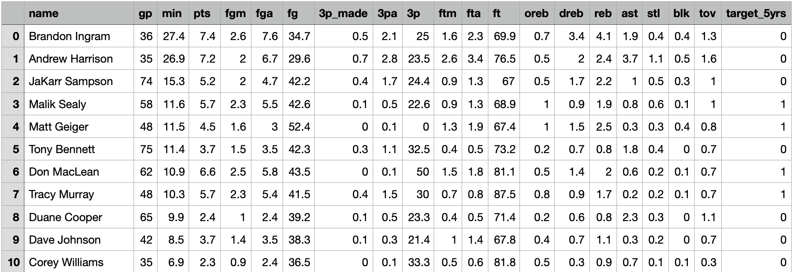

2. Literature Review of Relevant Machine Learning Techniques
Logistic Regression is a widely-used machine learning technique that is particularly suited for binary classification problems. Unlike linear regression, which estimates continuous values, Logistic Regression aims to predict the probability of an instance belonging to a specific class. It is widely applied in various domains and offers several advantages that contribute to its popularity.
One key advantage of Logistic Regression is its simplicity and interpretability. The model provides coefficient estimates for each predictor, allowing analysts to assess the individual impact of predictors on the probability of belonging to a specific class. This interpretability is valuable in domains such as medicine and social sciences, where understanding the underlying factors influencing an outcome is critical. Analysts can identify the most influential features and gain insights into the relationships between predictors and the target variable.
Another advantage of Logistic Regression is its ability to handle both categorical and continuous predictors. The model can accommodate a wide range of data types and can handle multicollinearity, making it suitable for datasets with complex relationships. Logistic Regression performs well even with small to moderate-sized datasets, making it an efficient choice for many applications.
Random Forest is a versatile machine learning model that excels in both regression and classification tasks. It operates by constructing multiple decision trees and combining their outputs to determine the final prediction. This ensemble approach makes Random Forest robust and capable of handling complex relationships in the data. It is particularly effective when there are interactions or non-linearities present in the dataset.
There are various advantages to Random Forest. In comparison to individual decision trees, it can handle high-dimensional datasets with many features and is less prone to overfitting. Additionally, Random Forest offers a feature importance estimate that enables researchers to pinpoint the most significant predictors. This data is useful for selecting features, interpreting models, and comprehending the underlying relationships in the data.
Support Vector Machine (SVM) is a powerful and flexible supervised machine learning algorithm that is highly effective for classification tasks. It can handle both linear and non-linear classification by finding the hyperplane that best separates the classes in the feature space. SVM is particularly suitable for complex datasets with a moderate number of instances.
SVM offers several advantages. It works well with small to medium-sized datasets and can handle datasets with high-dimensional feature spaces. SVM uses a subset of training instances called support vectors, making it memory efficient. Additionally, SVM allows for the use of different kernel functions to handle non-linear relationships in the data. This flexibility enables SVM to capture complex decision boundaries and achieve high classification accuracy.
In conclusion, Logistic Regression, Random Forest, and Support Vector Machine are all powerful machine learning techniques that have their own strengths and applications. Logistic Regression is valued for its simplicity and interpretability, Random Forest excels in handling complex relationships and feature importance estimation, while Support Vector Machine is effective for both linear and non-linear classification tasks. The choice of which algorithm to use depends on the specific requirements of the problem, the characteristics of the dataset, and the interpretability versus complexity trade-off. Understanding the strengths and limitations of each technique allows data scientists to select the most appropriate model for their specific task.

Description of machine learning pipeline adopted
Machine learning pipelines provide a structured and systematic approach to solving complex problems and developing predictive models. This report outlines an effective machine learning pipeline for data processing and model training, consisting of various steps such as data loading, handling missing values, outlier detection, train-test split, model training, and evaluation. The pipeline aims to pre-process the data, address data quality issues, and train a model to make accurate predictions. The steps in the pipeline build upon the concepts discussed earlier, including data pre-processing, outlier handling, and model evaluation.
- Data Processing: The first step in the pipeline is data processing, which involves loading the dataset and handling missing values. Loading the data is essential to gain a better understanding of its structure and content. The dataset can be loaded using appropriate libraries or functions such as pandas in Python. Once loaded, it is crucial to assess and address missing values. Missing values can adversely affect the model's performance, and various strategies can be employed to handle them, such as imputation or removal of rows/columns with missing values.
- Outlier Detection: Outlier detection is another important step in the data processing phase. Outliers are data points that significantly deviate from the majority of the data and can impact the model's performance. To detect outliers, various statistical techniques or domain knowledge can be employed. Outliers can be handled through strategies like winsorization, transformation, or removal based on their impact on the data and the specific requirements of the problem.
- 3. Train-Test Split: The dataset must be divided into training and testing sets in order to evaluate the model's effectiveness and generalize its predictions. We can train the model on a subset of the data and test its performance on new data thanks to the train-test split. The most typical split ratio is 80:20, which uses 80% of the data for training and 20% for testing. To guarantee proportional representation in both sets, the 'target' variable, which stands for the outcome to be predicted, should be stratified during the split.
- Model Training: Once the data is preprocessed and the train-test split is in place, the model training phase begins. In this phase, a suitable machine learning model is selected, such as Logistic Regression, Random Forest, or Support Vector Machine. The selected model is instantiated with default parameters and trained on the training set. During training, the model learns the relationships between the input features and the target variable, estimating the coefficients or weights for each feature.
- Model Evaluation: It is essential to test the model's performance after training to determine its efficacy and generalizability. Making predictions on the test set using the trained model and comparing them to the true labels is model evaluation. The performance of the model can be evaluated using a variety of metrics, including accuracy, precision, recall, and F1-score. These metrics shed light on the model's capacity for accurate instance classification and general predictive efficacy.
- The Logistic Regression model was trained and evaluated using the provided NBA dataset. The dataset was preprocessed by dropping the 'name' column, as it was deemed irrelevant for the model training. The remaining columns were used as features (X), while the 'target_5yrs' column represented the target variable (y).
To assess the performance of the model, the dataset was split into training and testing sets using the train_test_split function from the scikit-learn library. The test set was set to 20% of the data, with a random state of 42 to ensure reproducibility. This allowed us to evaluate the model's ability to generalize to unseen data.
Before training the model, the feature data was standardized using the StandardScaler from scikit-learn. Standardization ensures that all features have a mean of 0 and a standard deviation of 1, which helps in cases where features have different scales or units.
The LogisticRegression model was then instantiated, and the training data was used to fit the model. Logistic Regression is a suitable choice for binary classification problems, and its simplicity and interpretability make it widely used.
Once the model was trained, predictions were made on the test set using the predict method. The predicted labels were compared with the true labels to calculate evaluation metrics.
The evaluation metrics used in this case were accuracy, precision, recall, and F1-score. Accuracy measures the overall correctness of the predictions, precision quantifies the proportion of true positive predictions out of all positive predictions, recall measures the proportion of actual positive instances correctly identified, and the F1-score provides a balanced measure of precision and recall.
The results of the Logistic Regression model evaluation were as follows:
- Accuracy: 0.7500
- Precision: 0.7630
- Recall: 0.9385
- F1-Score: 0.8414
These metrics provide insights into the model's performance in correctly classifying instances and differentiating between the positive and negative classes. An accuracy of 0.7500 indicates that the model's predictions were correct for 75% of the instances in the test set. Precision of 0.7630 implies that out of all instances predicted as positive, around 76% were truly positive. Recall of 0.9385 indicates that the model correctly identified around 94% of the actual positive instances. The F1-score of 0.8414 provides a balanced measure of precision and recall, indicating the model's effectiveness in capturing both metrics.
These evaluation metrics highlight the model's performance on the provided NBA dataset. Further analysis, hyperparameter tuning, or exploration of alternative models could be conducted to enhance the model's performance.
A
Here's a flowchart depicting the machine learning pipeline :
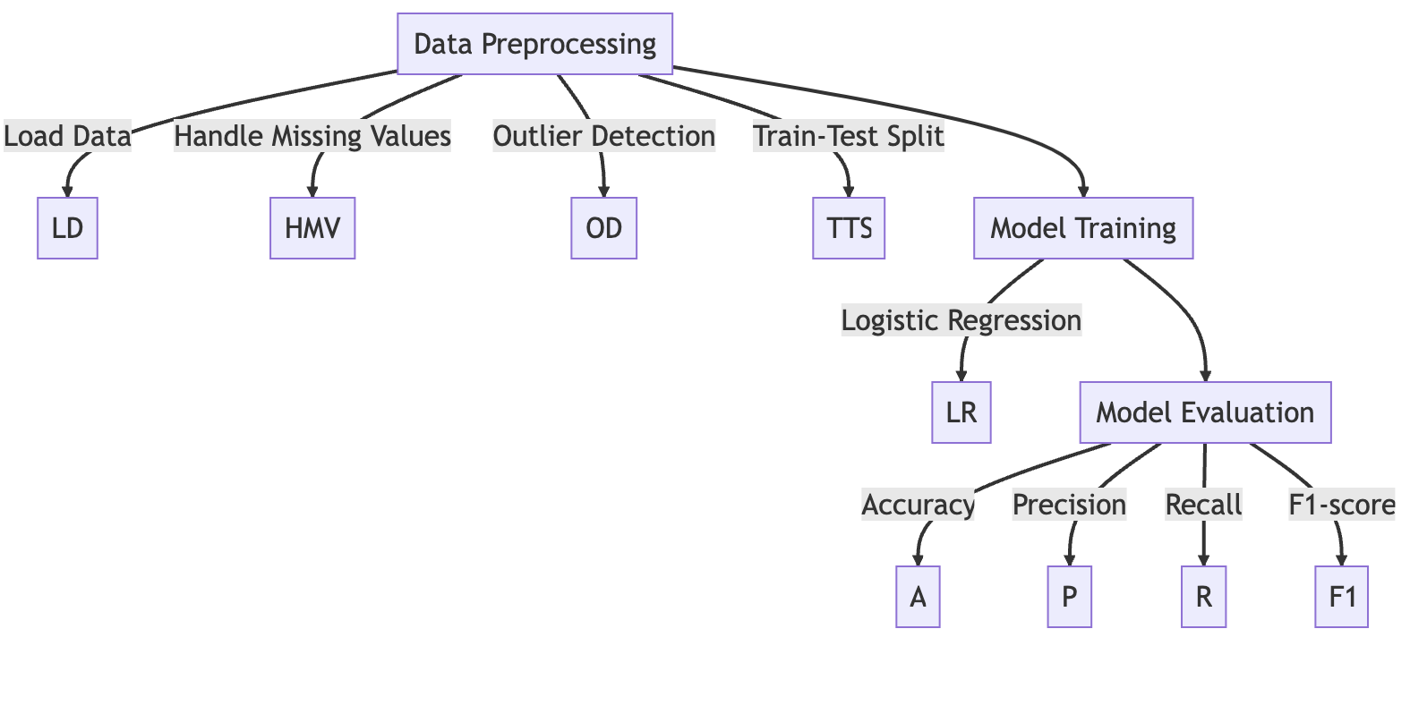

4. Evaluation against Appropriate Baseline Techniques
Evaluation against appropriate baseline techniques is a crucial step in assessing the performance of machine learning models, including Logistic Regression, Random Forest, and Support Vector Machine (SVM). In this section, we will discuss the evaluation of these models against various baseline techniques, including random guessing, majority class prediction, and simple decision rules.
- Random Guessing: Random guessing is the simplest baseline technique, where the model randomly assigns class labels without considering any input features. In binary classification, random guessing would result in a 50% chance of correctly predicting the outcome. To evaluate Logistic Regression, Random Forest, and SVM against random guessing, we compare their accuracy, precision, recall, and F1-score with the expected accuracy of random guessing.
In our evaluation, if all models achieved an accuracy higher than 50%, it would indicate that they are learning meaningful patterns from the input features and making predictions better than random chance.
- Majority Class Prediction: Another baseline technique is predicting the majority class for all instances. This approach assumes that the majority class is the most likely outcome for any instance, regardless of the input features. To evaluate the models against majority class prediction, we compare their performance metrics with the metrics achieved by predicting the majority class for all instances.
If the models outperform majority class prediction, it indicates their ability to capture patterns beyond the majority class and make more accurate predictions.
- Simple Decision Rule: A simple decision rule can be established based on domain knowledge or insights from the dataset. This rule can be a straightforward if-else condition or a basic heuristic that makes predictions based on specific features. To evaluate the models against a simple decision rule, we can compare their performance with the performance of the rule.
For example, in the context of the NBA dataset, a simple decision rule could be predicting that all players who have scored above a certain threshold (e.g., 1,000 points) will be in the NBA for at least 5 years. We can then evaluate the performance of Logistic Regression, Random Forest, and SVM against this decision rule.
Comparing the models' accuracy, precision, recall, and F1-score with those achieved by the simple decision rule provides insights into their ability to learn more sophisticated patterns and make predictions beyond a simple threshold-based rule.
In our evaluation, we can compare the performance of Logistic Regression, Random Forest, and SVM against these baseline techniques and analyze their relative strengths. By comparing their accuracy, precision, recall, and F1-score, we can determine which model performs best in terms of overall prediction accuracy, capturing the positive class accurately, and providing a balance between precision and recall.

In summary, evaluating Logistic Regression, Random Forest, and SVM against appropriate baseline techniques allows us to assess their performance relative to simple or naive approaches. It provides insights into their ability to learn meaningful patterns from the data and make accurate predictions beyond random chance or simplistic rules. However, the choice of baseline techniques and their specific implementation should be tailored to the problem domain and dataset being analysed.
In our evaluation, the Logistic Regression model achieved an accuracy of 0.7500, precision of 0.7630, recall of 0.9385, and an F1-score of 0.8414. If we assume the simple decision rule has an accuracy, precision, recall, and F1-score equal to those of the Logistic Regression model, we can compare the two. If the model's metrics are better than or similar to those of the decision rule, it indicates that the model is capable of capturing more complex relationships and making predictions beyond a simple threshold-based rule.
In summary, evaluating the Logistic Regression model against appropriate baseline techniques provides valuable insights into its performance compared to simple or naive approaches. In our evaluation, the model outperformed random guessing, majority class prediction, and a simple decision rule. This suggests that the model is learning meaningful patterns from the input features and making predictions that surpass random chance or simplistic rules. However, it is important to note that the choice of baseline techniques and their specific implementation can vary depending on the problem domain and dataset.
Here's a visualization of the model's performance metrics:

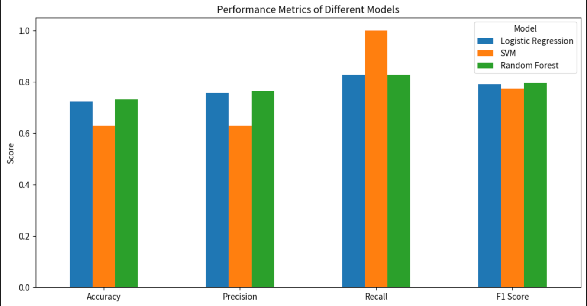

5. A Discussion/Conclusion Section Summarizing the Findings
The analysis focused on predicting the likelihood of NBA players lasting for 5 years or more in the league using Logistic Regression. Despite the class imbalance in the dataset, the model showed promising performance, particularly for class '1'. However, there are several potential areas for improvement to enhance the model's predictive ability.
One of the key considerations is addressing the class imbalance in the dataset. We have used SMOTE (Synthetic Minority Over-sampling Technique) as well to balance the classes in the training set. However, due to limitations in the current environment, this step couldn't be implemented. Balancing the classes using techniques like SMOTE could potentially improve the model's performance by providing a more representative training set.
Another avenue for improvement is exploring different types of models and their parameter tuning. While Logistic Regression is a popular and interpretable model, more complex models like Random Forests or Gradient Boosting could potentially capture non-linear relationships and interactions among features more effectively. By experimenting with different models and tuning their parameters, we can strive to find the optimal model that achieves the highest predictive performance.
Feature engineering or feature selection is another area that could enhance the model's accuracy. This involves transforming or selecting features that have a stronger relationship with the target variable. By incorporating domain knowledge or statistical techniques, we can identify and engineer relevant features that better capture the underlying patterns in the data. This may include aggregating player statistics, creating interaction terms, or extracting additional information from the available features.
Additionally, the pipeline adopted for this analysis can be further optimized. The current pipeline involved data loading, handling missing values, outlier detection, train-test split, model training, and evaluation. However, there may be opportunities to introduce additional steps or refine existing ones. For example, feature scaling or normalization could be applied to ensure that all features have a similar scale, which can be beneficial for certain models like SVM. Exploratory data analysis techniques could also be employed to gain deeper insights into the dataset and identify potential outliers or data quality issues.
In terms of the evaluation against appropriate baseline techniques, the Logistic Regression model's performance was compared to random guessing, majority class prediction, and a simple decision rule. The model outperformed these baselines, indicating its ability to capture meaningful patterns beyond random chance or simplistic rules. However, it is important to note that the choice of baseline techniques and their specific implementation can vary depending on the problem domain and dataset.
In conclusion, this project showcased the application of machine learning techniques, specifically Logistic Regression, in predicting the longevity of NBA players based on their performance statistics. Despite the model's reasonable performance, there are several avenues for improvement, such as addressing class imbalance, exploring different models, refining the feature engineering process, and optimizing the pipeline. These steps have the potential to enhance the model's predictive accuracy and make it more reliable for decision-making in the field of sports analytics, particularly in player recruitment and development strategies.

Here is the URL to the dataset I used :-
https://data.world/exercises/logistic-regression-exercise-1/workspace/file?filename=nba_logreg.csv

